**PRACTICAL NO:-1**

**1) Write a program which takes name and age from the user on click of button and display a message on label, user is eligible or not**

**Code:-**

**package p1;**

**import java.awt.BorderLayout;**

**import java.awt.EventQueue;**

**import javax.swing.JFrame;**

**import javax.swing.JPanel;**

**import javax.swing.border.EmptyBorder;**

**import javax.swing.JLabel;**

**import javax.swing.JTextField;**

**import javax.swing.JButton;**

**import java.awt.event.ActionListener;**

**import java.awt.event.ActionEvent;**

**import java.awt.Color;**

**import java.awt.Font;**

**public class voters extends JFrame {**

**private JPanel contentPane;**

**private JTextField txtName;**

**private JTextField txtAge;**

**JLabel l1;**

**public static void main(String[] args) {**

**EventQueue.invokeLater(new Runnable() {**

**public void run() {**

**try {**

**voters frame = new voters();**

**frame.setVisible(true);**

**} catch (Exception e) {**

**e.printStackTrace();**

**}**

**}**

**});**

**}**

**public voters() {**

**setDefaultCloseOperation(JFrame.EXIT_ON_CLOSE);**

**setBounds(100, 100, 459, 296);**

**contentPane = new JPanel();**

**contentPane.setBorder(new EmptyBorder(5, 5, 5, 5));**

**setContentPane(contentPane);**

**contentPane.setLayout(null);**

**JLabel lblNewLabel = new JLabel("Name");**

**lblNewLabel.setFont(new Font("Tahoma", Font.BOLD, 14));**

**lblNewLabel.setBounds(48, 59, 46, 14);**

**contentPane.add(lblNewLabel);**

**JLabel lblNewLabel_1 = new JLabel("Age");**

**lblNewLabel_1.setFont(new Font("Tahoma", Font.BOLD, 14));**

**lblNewLabel_1.setBounds(48, 104, 46, 14);**

**contentPane.add(lblNewLabel_1);**

**txtName = new JTextField();**

**txtName.setBounds(143, 56, 86, 20);**

**contentPane.add(txtName);**

**txtName.setColumns(10);**

**txtAge = new JTextField();**

**txtAge.setBounds(143, 101, 86, 20);**

**contentPane.add(txtAge);**

**txtAge.setColumns(10);**

**JLabel l1 = new JLabel();**

**l1.setBounds(65, 175, 147, 14);**

**contentPane.add(l1);**

**JButton btnNewButton = new JButton("validity");**

**btnNewButton.setFont(new Font("Tahoma", Font.BOLD, 14));**

**btnNewButton.addActionListener(new ActionListener() {**

**public void actionPerformed(ActionEvent e) {**

**String a = txtName.getText();**

**int b = Integer.parseInt(txtAge.getText());**

**if(b>=18) {**

**l1.setText("You are eligible to vote");**

**}**

**else**

**l1.setText("You are not eligible to vote");**

**}**

**});**

**btnNewButton.setBounds(48, 142, 98, 23);**

**contentPane.add(btnNewButton);**

**JButton btnNewButton_1 = new JButton("Reset");**

**btnNewButton_1.setFont(new Font("Tahoma", Font.BOLD, 14));**

**btnNewButton_1.addActionListener(new ActionListener() {**

**public void actionPerformed(ActionEvent e) {**

**txtName.setText("");**

**txtAge.setText("");**

**}**

**});**

**btnNewButton_1.setBounds(208, 144, 85, 21);**

**contentPane.add(btnNewButton_1);**

**}**

**}**

**Output:-**

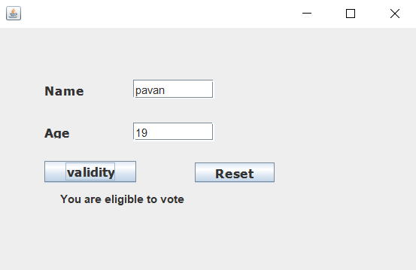

**2)Write a program to create a Combobox, textfield and button and on click of button the value of textfield should be added to combobox.**

**import javax.swing.*;**

**import java.awt.*;**

**import java.awt.event.*;**

**public class A5{**

**public static void main(String[] args) {**

**comb obj = new comb();**

**//g = obj.getContentPane();**

**}**

**}**

**class comb extends JFrame {**

**public comb() {**

**setLayout(new FlowLayout());**

**setSize(400,400);**

**setVisible(true);**

**setDefaultCloseOperation(JFrame.*EXIT_ON_CLOSE*);**

**JComboBox jcb = new JComboBox();**

**JTextField t = new JTextField(10);**

**add(t);**

**JButton b = new JButton("Add Item");**

**add(b);**

**add(jcb);**

**b.addActionListener(new ActionListener() {**

**public void actionPerformed(ActionEvent ae) {**

**jcb.addItem(t.getText());**

**t.setText("");**

**}**

**});**

**}**

**}**

**Output:-**

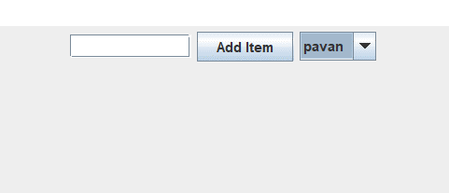

**3) Write a program that creates a list containing ice-cream flavours.  On selection of any flavour price should be displayed in text field.**

**Code:-**

**import java.awt.event.*;**

**import java.awt.*;**

**import javax.swing.*;**

**import javax.swing.event.ListSelectionEvent;**

**import javax.swing.event.ListSelectionListener;**

**public class Flavours extends JFrame implements ListSelectionListener {**

**JList l1;**

**JTextArea t1;**

**JLabel l2,l3;**

**public Flavours()**

**{**

**setLayout(new FlowLayout());**

**l2 = new JLabel("Select Flavour");**

**l3= new JLabel("Selected Flavour");**

**String[] flavour = new String[] {"Vanilla","Chocolate","Mango","Strawberry"};**

**l1=new JList(flavour);**

**l1.addListSelectionListener(this);**

**t1=new JTextArea(3,5);**

**add(l2);**

**add(l1);**

**add(l3);**

**add(t1);**

**setVisible(true);**

**setSize(500,500);**

**setDefaultCloseOperation(JFrame.EXIT_ON_CLOSE);**

**}**

**public void valueChanged(ListSelectionEvent e) {**

**Object[] obj = l1.getSelectedValues();{**

**String str = "You Selected";**

**for(int i=0;i<obj.length;i++) {**

**str += obj[i]+" ";**

**}**

**t1.setText(str);**

**}**

**}**

**public static void main(String[] args) {**

**new Flavours();**

**}**

**}**

**Output:-**

